**I. The first case: φd(σ) = 0 and I(σ) is symmetric.**

When the distribution of *I′*(*σ*) is symmetric is evenly symmetric about the origin, *A(2z)=A(-2z)* and . *I′*(*σ*) is shown in Fig.2. When *I′*(*σ*) is translated by from the origin to the right, it is equal to that the distribution of *I*(*σ*) is symmetric with a central wavenumber , and .



According to the space shifting property of Fourier transform, the effect of a space shift *-z0*on a space signal is to introduce into its transform a phase of shift, namely, *-4πz0σ*, which is a linear function of σ. By this property Eq.(9) is obtained from Eq.(8).



In the case of , the distributions of *SC*(*z*) are shown in Figs.3(a c) and (b d).



Fig. 2 The distribution ofand spectral intensity

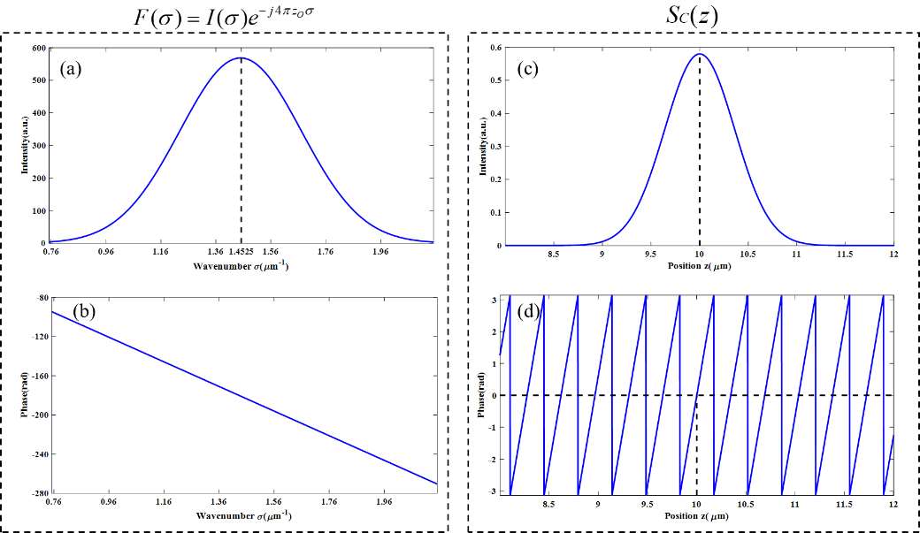

Figs. 3 IFT (Inverse Fourier transform) of *F(σ)*. (a) The intensity of *F(σ)*. (b) The phase of *F(σ)*.

(c) The intensity of *SC(z)*. (d)The phase of *SC(z).*

According to the Eq.(9), when the amplitude distribution of *SC*(*z*) is *A*(*2*(*z-zO*)) and the phase distribution of *SC*(*z*) is ~~4~~*~~πz~~~~0~~~~σ~~* 4*πσC*(*z-zO*), the spectral phase is given by .

So, the peak position in the amplitude distribution of *SC*(*z*) is *za=zo*, and the zero phase position nearest z=*za* is *zp=zo*. The period of the wrapped phase distribution is



Fig.3 shows the simulation about the IFT(Inverse Fourier transform) of *F(σ)*. The relevant parameters of *F(σ)* and *SC(z)* are shown in Table 1 and Table 2.

Table 1. The parameters of F(σ) shown in Figs.3 (a) and (b)

|  |  |  |
| --- | --- | --- |
| σC | zO | λC |
| 1.4525μm-1 | 10μm | 0.6884μm |

σC: Central wavenumber of *I(σ)*.

zO: The position of an object surface.

λC: Central wavelength of *I(λ)* and *λC = 1/σC.*

**Table 2 Simulation results shown in Figs.3 (c) and (d).**

|  |  |  |
| --- | --- | --- |
| za | zp | P |
| 10.0000μm | 10.0000μm | 0.3448μm |

za : The peak position in the amplitude distribution of *SC*(*z*).

zp : The zero-phase position in the phase distribution of *SC*(*z*).

P : The period of the unwrapped phase distribution of SC(z).

supplementary data：

The unwrap phase of SC(z) as shown below.

